Week 7 Pre-Lab and Lab (Figure and HTML Endpoints)
ALL of these endpoints should be complete by the END OF LAB THIS WEEK!

At this point, /prediction and /performance endpoints should be complete. If they are not, you need to do them before /figure and HTML endpoints.

Resources:
WATCH WEEK 6 WALK-THROUGH VIDEO (Canvas > Week 6 Module)

I have also posted my example to Week 7. Please feel free to use that material to customize for your own service. It is advised to copy your last week (functioning) app folder into your new Week 7 material. Then, copy/paste any material from my E222_Student repository that you might need.

- /prediction endpoint (2 points)
  - Create a /prediction endpoint in your master.yml file. This file should be a POST that allows someone to upload a file to the server (like testdata.csv) and return a list of resulting predictions. Use the appropriate syntax. I recommend you doing this in your Swagger Editor and copy/paste your VM master.yml file when complete.
  - Note there a file_predict function in model.py (see below). It is not finished as it needs YOUR model to be loaded. This means you need to make sure your pkl file is in the same directory (src folder) as this script). Make those updates (HINT: Use your upload file endpoint to get your model pkl file onto your VM).
  - Test your service. Make sure that any installations are updated in your requirements.txt file.
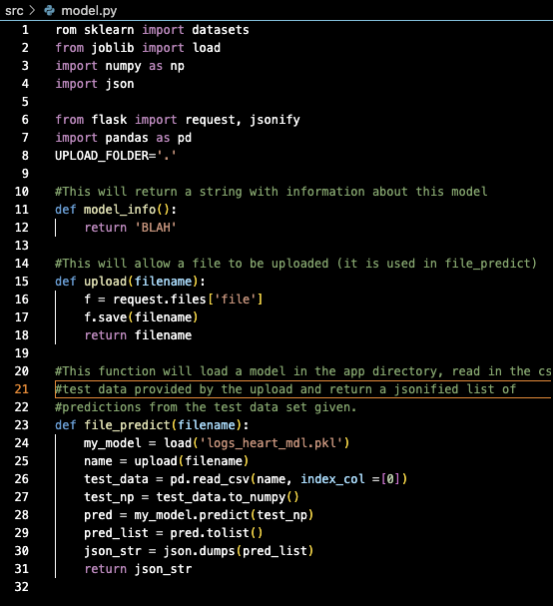

- /performance endpoint (2 points)
  - Create a /performance endpoint that provides accuracy or whatever performance metric you used to the user.
  - No function has been created to do this. You will need to either create a new py file OR include it in the model.py script.

NOTE: To see HTML rendered pages, please go to (replace with your IP address):
http://0.0.0.0:8080/ (for the landing page)
http://0.0.0.0:8080/html/hello_template.html (for a test after endpoints/code are added)
http://0.0.0.0:8080/html/new.html (for your image after endpoints/code are added)

- Landing (HTML) page for our service (2 pt)
  - Go into templates and edit the html to say something about your service in the body. I did something like this:
<!DOCTYPE html>
<html lang="en">
<head>
<meta charset="UTF-8">
<title>Heart Disease Classification</title>
</head>
<body>
<h1>Heart Disease Classification</h1>
<h2>This application will provide likelihood predictions for heart disease in patients.</h2>
</body>
</html>

  - Then go to server.py and change the route to the to render the html page instead of “It’s working”
# create a URL route in our application for "/"
@app.route("/")
def home():
return(render_template('index.html'))
#def home():
# msg = {"msg": "It's working!"}
# return jsonify(msg)
  - Test it out on Jetstream2
  - While you are in server.py, create another route – we will use it later:
@app.route("/html/<page>")
def html_hello(page):
return render_template(page)

- /figure endpoint (4 pt): Create an endpoint that provides a figure for your service. Below is code that provides a histogram. You can change this if you would like. Also note there are some functions that have some HTML implications – include for later!

figure.py
from sklearn import datasets
from joblib import load
import numpy as np
import json
from flask import Flask, send_file, render_template
import os
import io
from flask import request, jsonify
import pandas as pd
import matplotlib
matplotlib.use('Agg') # Use the Agg backend for non-GUI rendering
import matplotlib.pyplot as plt

# Functions in this file assume there is a file available in directory on the server
# to provide images.

# This function takes in the name of the file to be read (input as a query parameter)
# This file should be present on the server.
# It then reads a CSV file, generates a histogram plot from the data, and saves the plot
# as a PNG image in a BytesIO object. The image is then returned as a BytesIO object.
# A BytesIO object is a binary stream that allows data transmission to be more efficient.
def gen_plot(filename):
try:
# This will look for a file ALREADY on the server
# with the name entered in the query parameter - called filename.
name = request.args.get('filename') # this is the name of the query parameter
if not name:
return jsonify({"error": "Invalid input"}), 405
test_data = pd.read_csv(name, index_col =[0])
test_data.plot(kind='hist').get_figure() #Change this if you want!
bytes_image = io.BytesIO()
plt.savefig(bytes_image, format = 'png')
bytes_image.seek(0)
return bytes_image
except KeyError as e:
return jsonify({"error": str(e)}), 400

# This function takes in the name of the file to be read (input as a query parameter)
# This file should be present on the server.
# This function generates a plot using the gen_plot function and returns the image as a response
# with MIME (Multipurpose Internet Mail Extensions ) type 'image/png'.
# Example of MIME types are
# text/html: HTML document
# image/jpeg: JPEG image
# application/json: JSON data
# application/pdf: PDF document
# JSON is usually text while BINARY FILES are usually for images (Flask send_file)
# Hence, it returns a Flask response object containing the image data with MIME type 'image/png'.
def disp_plot(filename):
plot = gen_plot(filename)
return send_file(plot, mimetype='image/png')

# This function takes in the name of the file to be read (input as a query parameter)
# This file should be present on the server.
# This function reads a CSV file, generates a histogram plot from the data, saves the plot as a PNG
# image in the 'static/images' directory, and renders the 'new.html' template to display the image.
# Then, it returns a Flask response object rendering the 'new.html' template.
def html(filename):
try:
# This will look for a file ALREADY on the server
# with the name entered in the query parameter - called filename.
name = request.args.get('filename') # this is the name of the query parameter
if not name:
return jsonify({"error": "Invalid input"}), 405

test_data = pd.read_csv(name, index_col=[0])
plot = test_data.plot(kind='hist').get_figure()
plot_path = os.path.join('static', 'images', 'plot.png') #Change this if you want!
plot.savefig(plot_path)
return render_template('new.html')
except FileNotFoundError:
return jsonify({"error": "File not found"}), 404

#This function returns a Flask response object rendering
# the 'hello_template.html' template.
def html_hello():
return render_template('hello_template.html')

- /figure endpoint and /html endpoints
  - Let’s add a figure endpoint to our master.yml/html and /hello_html endpoints in the master.yml file:

Figure endpoint:
/figure:
get:
tags:
- Figure
operationId: src.figure.disp_plot
description: Returns a histogram of the data file
parameters:
- name: filename
in: query
description: name of file present on server
required: true
schema:
type: string
responses:
'200':
description: 'Success'
content:
image/png:
schema:
type: string
format: binary
'400':
description: 'Bad Request'
content:
application/json:
schema:
type: object
properties:
error:
type: string
example: "Invalid input"

HTML Endpoints (2):
/html:
get:
tags:
- Figure
operationId: src.figure.html
description: Returns html that displays a figure (new.html)
parameters:
- name: filename
in: query
description: name of file present on server
required: true
schema:
type: string
responses:
'200':
description: 'Success'

/hello_html:
get:
tags:
- Demo
operationId: src.figure.html_hello
description: Returns hello world string inside HTML template
responses:
'200':
description: 'Success'
NOTE: To see HTML rendered pages, please go to (replace with your IP address):
http://0.0.0.0:8080/ (for the landing page)
http://0.0.0.0:8080/html/hello_template.html (for a test after endpoints/code are added)
http://0.0.0.0:8080/html/new.html (for your image after endpoints/code are added)

